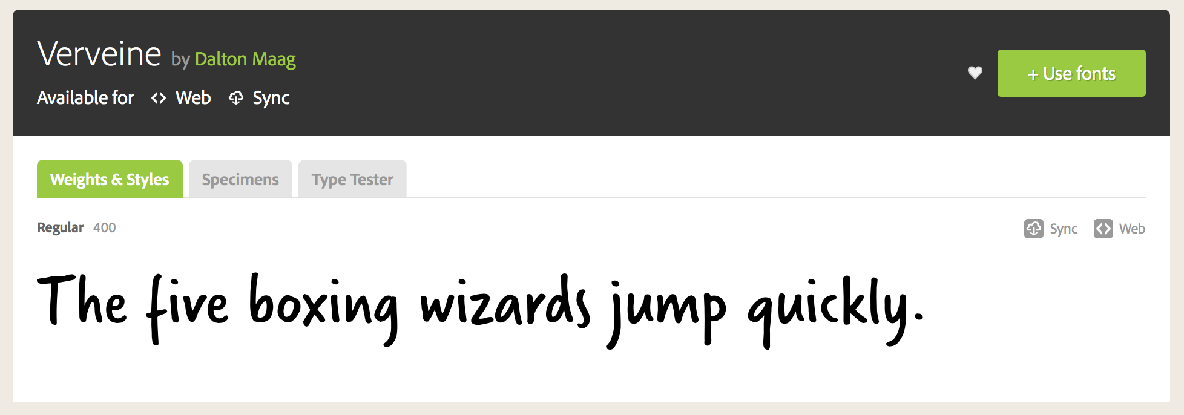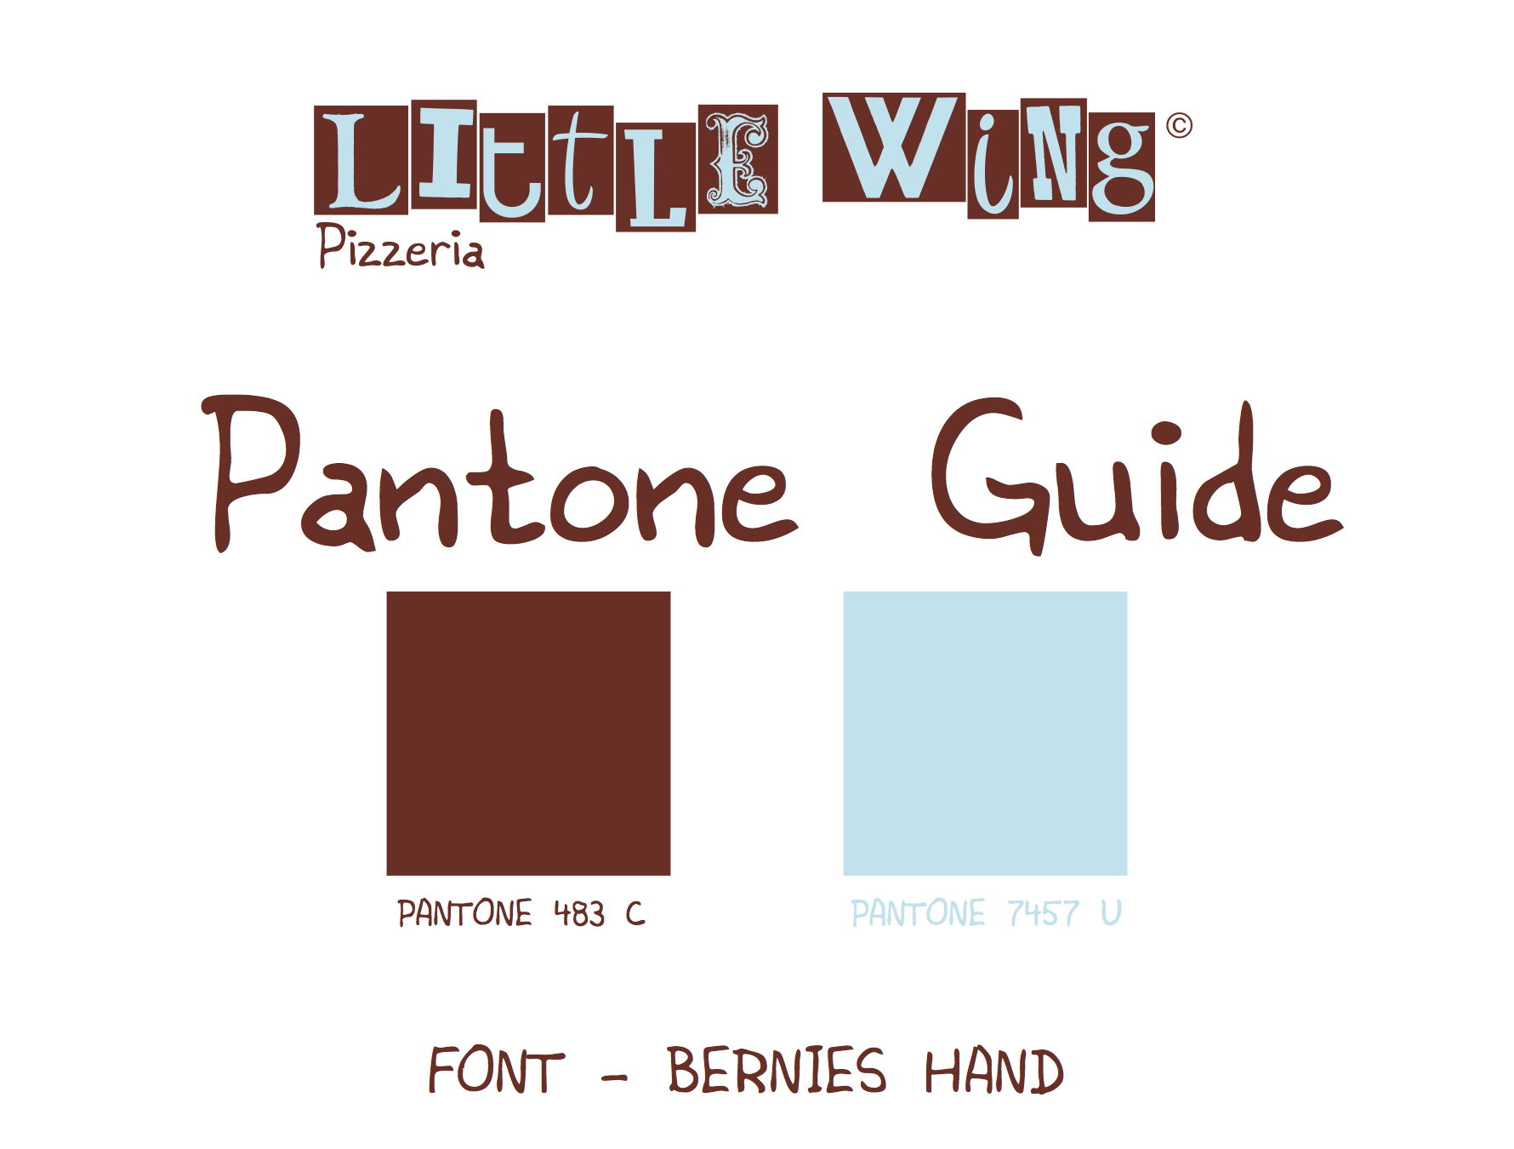Macintosh HD:Users:hayleygregg:Desktop:Little Wing:little-wing graphics:bluepizzabground.pdf